Business Analytics Report
Customer Churn Analysis — Telco Customer Churn Dataset
Prepared for: Data Analytics Internship Programme, AnalystLab Africa

Part 1 — Business Understanding

1.1 Background
Customer churn — the rate at which customers stop doing business with a company — is one of the most closely watched metrics in subscription-based industries such as telecommunications, banking, insurance, and streaming media. In competitive, saturated markets, acquiring a new customer typically costs significantly more than retaining an existing one, which makes churn reduction a direct lever on profitability rather than just a satisfaction metric.
In the telecommunications sector specifically, churn is driven by a mix of price sensitivity, contract flexibility, service quality (particularly internet reliability), customer support experience, and the availability of competing providers. Because customers can typically switch providers with relatively low friction (portability of phone numbers, short or month-to-month contracts), telecom companies must proactively identify at-risk customers rather than react after they leave.

1.2 Business Problem
The organisation in this dataset offers phone and internet services and wants to understand why 26.5% of its customer base has churned. Without a clear, data-driven understanding of churn drivers, retention spend (discounts, outreach, loyalty offers) is allocated inefficiently — either spread too thinly across the whole base or targeted using guesswork rather than evidence.

1.3 Objectives
- Quantify the overall churn rate and identify which customer segments churn most.
- Determine which service, contract, and billing attributes are most strongly associated with churn.
- Translate findings into concrete, actionable retention recommendations.
- Provide a reusable analytical foundation (dataset inspection, visual analysis) for ongoing churn monitoring.

1.4 Key Business Questions

1. What does the customer base look like?

2. Which segments have the highest churn?

3. Does contract type influence retention?

4. Does tenure affect loyalty?

5.Which services influence churn?

6. Which payment methods have higher churn?

1.5 Stakeholders
Stakeholder | Interest
Customer Retention / CX team | Design targeted interventions for at-risk segments
Marketing & Pricing | Adjust contract incentives and pricing bundles
Network / Product team | Investigate service-quality issues (e.g., fibre optic complaints)
Finance / Leadership | Understand revenue-at-risk and prioritise retention budget

1.6 Success Criteria
This analysis is considered successful if it produces (a) a clear quantification of churn and its main drivers, (b) visual evidence that a non-technical stakeholder can interpret without statistical training, and (c) at least five specific, actionable recommendations the business can implement within one to two quarters.

Part 3 — Business Data Analysis
Nine visualisations were produced to explore churn from multiple angles: bar charts for categorical churn drivers, pie charts for composition, histograms for numeric distributions, a box plot comparing spend by churn status, and a correlation heatmap of numeric fields.

3.1 Bar Chart — Churn Rate by Contract Type
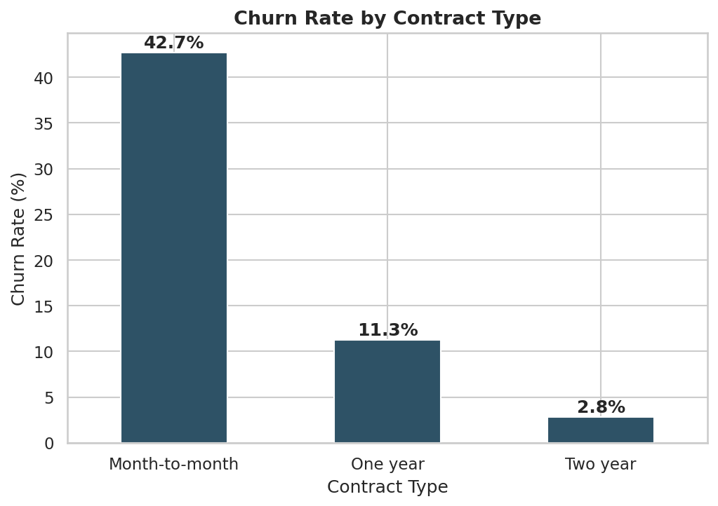
Figure 1: Churn rate (%) by contract type.
Month-to-month customers churn at 42.71%, more than 3.5x the rate of one-year contracts (11.27%) and roughly 15x the rate of two-year contracts (2.83%). Contract length is the single strongest churn signal in the dataset — customers with no long-term commitment churn overwhelmingly more often.

3.2 Bar Chart — Churn Rate by Internet Service
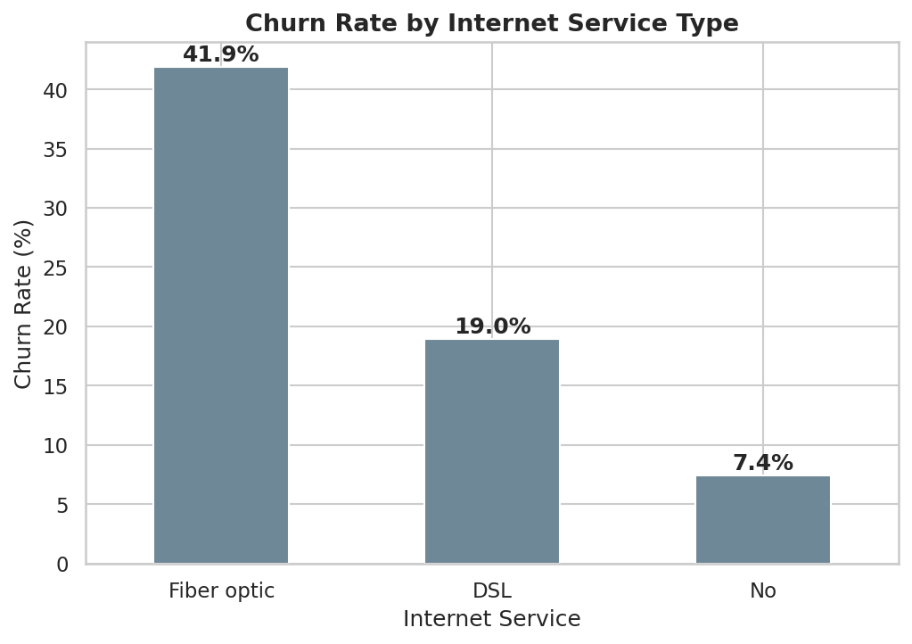
Figure 2: Churn rate (%) by internet service type.
Fibre-optic customers churn at 41.89%, more than double the DSL rate (18.96%) and nearly 6x the rate of customers with no internet service (7.4%). Despite being a premium, higher-bandwidth product, fibre optic is the company's leakiest service line — pointing to possible price, reliability, or competitive pressure issues specific to that product.

3.3 Bar Chart — Churn Rate by Payment Method
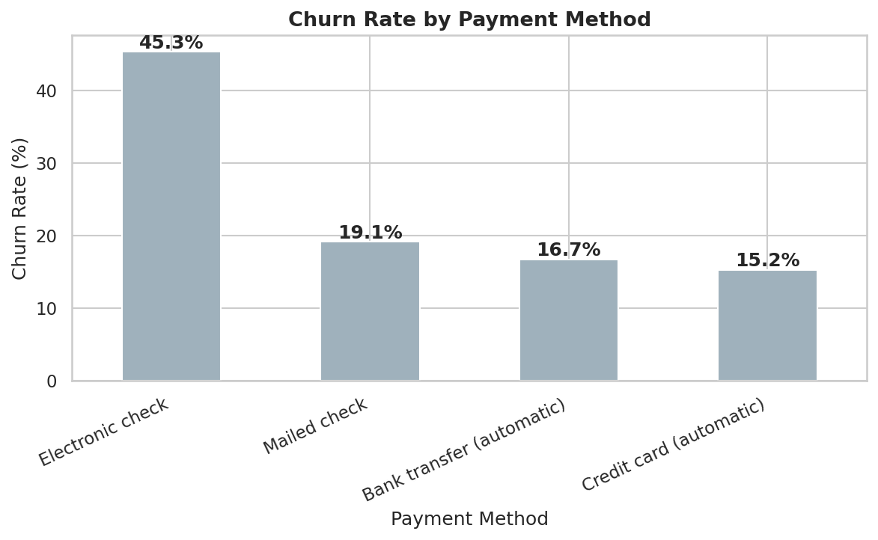
Figure 3: Churn rate (%) by payment method.
Electronic check users churn at 45.29%, nearly triple the rate of customers on automatic bank transfer (16.71%) or automatic credit card payment (15.24%). Manual, non-automated payment methods correlate strongly with higher churn, likely reflecting a segment of less-committed or more price-conscious customers.

3.4 Bar Chart — Churn Rate by Senior Citizen Status
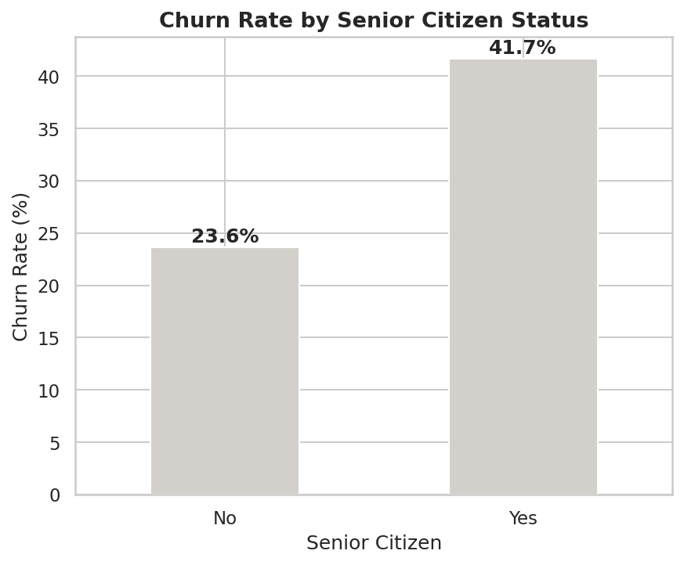
Figure 4: Churn rate (%) by senior citizen status.
Senior citizens churn at 41.68%, compared to 23.61% for non-seniors — nearly double the rate. Although seniors are a minority of the customer base, they represent a disproportionately at-risk segment worth targeted outreach.

3.5 Pie Chart — Overall Churn Distribution
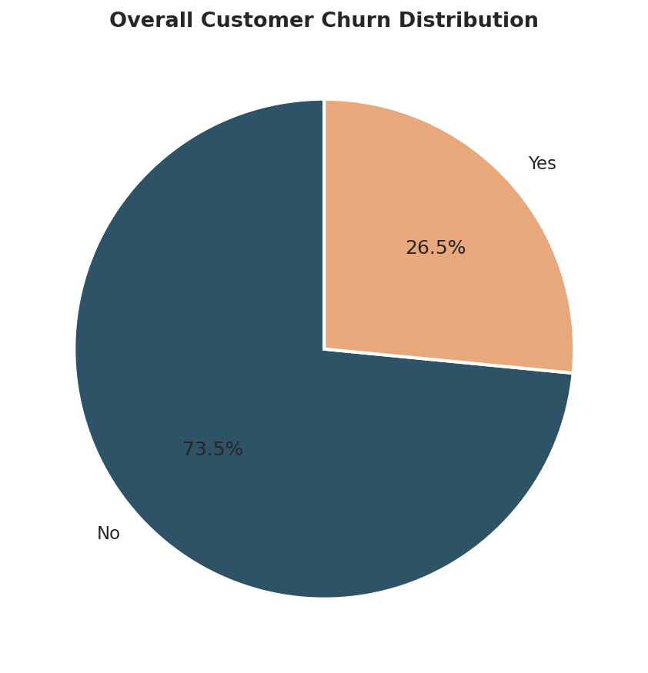
Figure 5: Proportion of customers who churned vs. retained.
Of 7043 customers, 1869 (26.54%) churned and 5174 were retained. A churn rate above one in four customers is high for a subscription business and represents a material, recurring revenue loss if left unaddressed.

3.6 Pie Chart — Contract Type Distribution
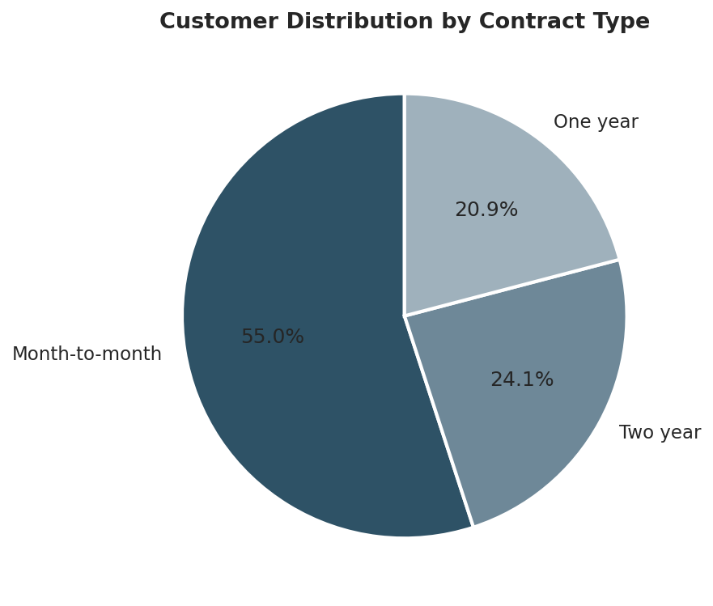
Figure 6: Composition of the customer base by contract type.
55.0% of all customers are on month-to-month contracts — the exact segment identified in Figure 1 as having the highest churn rate. This means the majority of the customer base sits in the highest-risk contract category, amplifying the business impact of contract-driven churn.

3.7 Histogram — Tenure Distribution
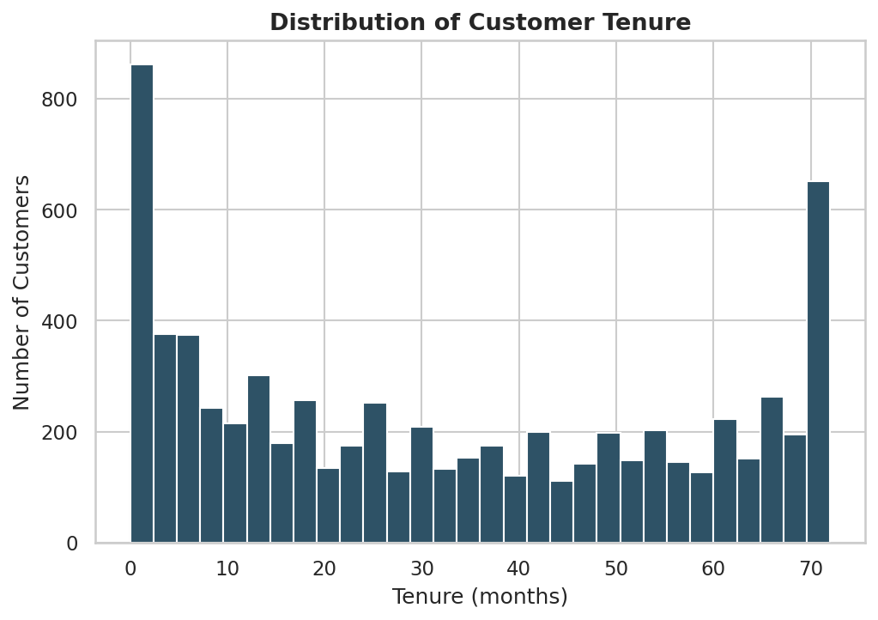
Figure 7: Distribution of customer tenure (months).
Tenure is bimodal: a large spike of customers in their first few months, a broad middle, and a second spike near 72 months (the maximum observed). This suggests two distinct populations — customers who churn early (often within the first year) and a loyal core that stays for the long term, with fewer customers in between.

3.8 Histogram — Monthly Charges Distribution
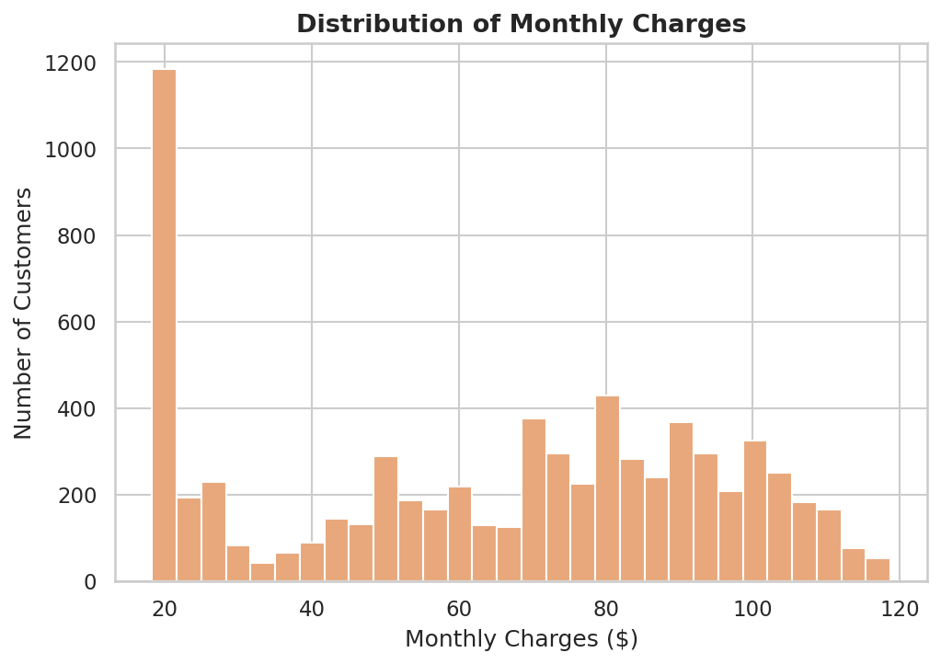
Figure 8: Distribution of monthly charges ($).
Monthly charges show two clusters: a large group paying $20–$30 (customers likely without internet, phone-only), and a broad group paying $65–$100 (bundled internet/fibre customers). This bimodal pattern reflects distinct product tiers rather than a smooth pricing curve.

3.9 Box Plot — Monthly Charges by Churn Status
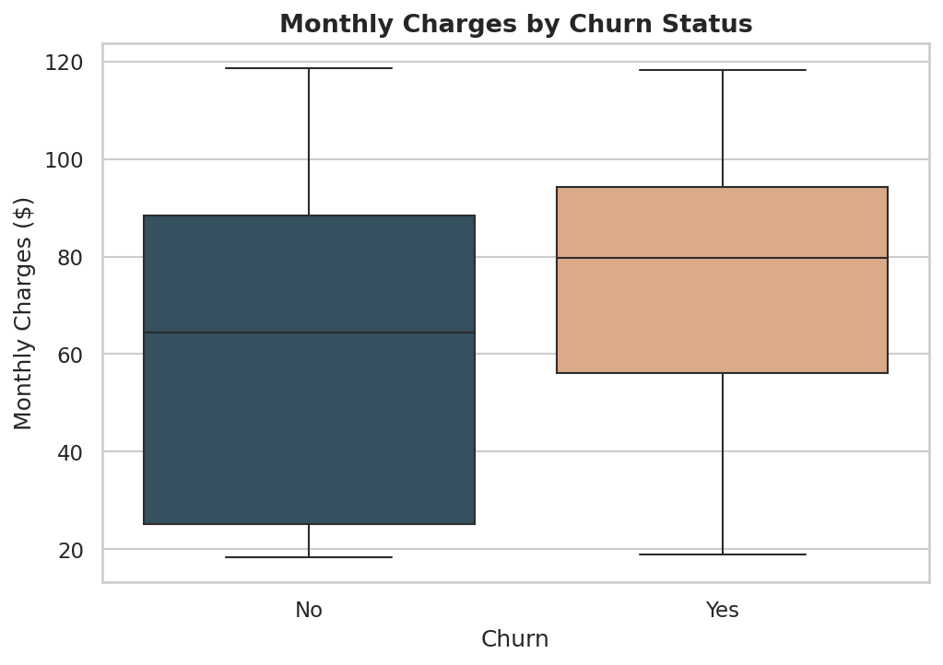
Figure 9: Monthly charges distribution split by churn status.
Churned customers have a notably higher median monthly charge ($79.65) than retained customers ($64.43). Combined with the contract and internet-service findings, this suggests that customers paying more — often fibre-optic, month-to-month subscribers — are the most price-sensitive and flight-prone segment.

3.10 Correlation Heatmap
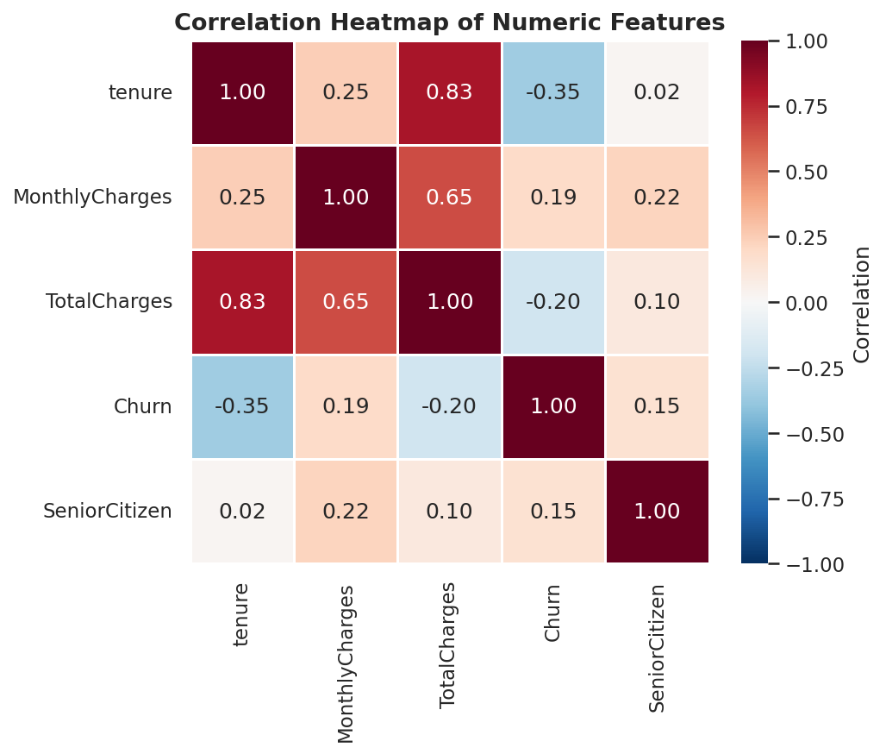
Figure 10: Correlation heatmap of numeric fields (tenure, MonthlyCharges, TotalCharges, Churn, SeniorCitizen).
Tenure has the strongest correlation with churn (-0.35) — the negative sign confirms that longer-tenured customers are markedly less likely to churn. MonthlyCharges shows a positive correlation with churn (0.19), reinforcing that higher bills are associated with higher churn risk. TotalCharges correlates strongly with tenure (0.83), which is expected since total spend accumulates over time.

Part 4 — Business Insights

4.1 Five Key Insights
1. Contract length is the dominant churn driver. Month-to-month customers churn at 42.7%, versus 11.3% for one-year and just 2.8% for two-year contracts — a difference of over 15x between the extremes.
2. Fibre-optic internet customers are disproportionately at risk. Despite being the premium product, fibre optic has the highest churn rate (41.9%) of any internet service tier, suggesting service quality, price, or competitive issues specific to this product.
3. Manual payment methods signal disengagement. Customers paying via electronic check churn at 45.3%, nearly 3x the rate of customers on automatic payment methods — automatic payments may be a proxy for higher commitment.
4. Tenure and churn are strongly inversely related. New customers (low tenure) are far more likely to churn than long-tenured ones; the first year of the customer relationship is the highest-risk period.
5. Senior citizens churn at nearly double the rate of non-seniors (41.7% vs. 23.6%), despite being a smaller segment of the overall base — indicating a specific unmet need in this group (e.g., support, pricing, or usability).

4.2 Business Risks
- Revenue concentration risk: With month-to-month customers making up over half the customer base and churning at the highest rate, a large share of recurring revenue is structurally exposed and unstable.
- Premium product risk: The company's flagship fibre-optic offering — likely its highest-margin product — has the weakest retention, threatening both revenue and the brand's competitive positioning as a premium provider.
- Early-life attrition risk: A large share of churn happens in customers' first year, meaning acquisition spend is being lost quickly, which suppresses customer lifetime value (LTV) and return on acquisition cost.

4.3 Business Opportunities
- Contract migration: Incentivising month-to-month customers to move to one- or two-year contracts (via modest discounts or perks) could substantially cut churn, since two-year customers churn 15x less often.
- Payment method conversion: Encouraging electronic-check users to switch to automatic bank transfer or credit card payment is a low-cost, low-friction intervention with a clear churn-reduction signal.
- Segment-specific retention offers: Targeted campaigns for fibre-optic subscribers and senior citizens — the two highest-risk segments — could yield an outsized reduction in overall churn relative to a blanket, undifferentiated retention program.

Part 5 — Business Recommendations
1. Launch a contract upgrade campaign: Offer month-to-month customers a modest discount or value-add (e.g., one month free, priority support) to migrate to a one- or two-year contract, prioritising customers in their first 6 months of tenure.
2. Investigate fibre-optic service quality and pricing: Conduct a focused review (network reliability, competitor pricing, customer support tickets) specifically for fibre-optic subscribers to identify the root cause of the 41.9% churn rate.
3. Promote automatic payment enrolment: Run a campaign encouraging electronic-check customers to switch to automatic bank transfer or credit card payment, using a small one-time incentive (e.g., bill credit) to drive adoption.
4. Strengthen new-customer onboarding: Introduce a structured first-90-days engagement program (welcome calls, usage tips, proactive support check-ins) to reduce early-tenure churn, the period where risk is highest.
5. Build a senior-citizen retention track: Develop simplified pricing plans, accessible customer support options, and proactive outreach specifically for senior customers, who churn at nearly double the rate of non-seniors.
6. Deploy a churn-risk scoring model: Use the patterns identified here (contract type, internet service, payment method, tenure, monthly charges) as inputs to a predictive model that flags at-risk customers before they churn, enabling proactive rather than reactive retention.

Conclusion
This analysis shows that churn at this company is not random — it is concentrated in specific, identifiable segments: month-to-month contracts, fibre-optic subscribers, electronic-check payers, new customers, and senior citizens. Because these drivers are concrete and actionable, targeted retention investment in these segments should yield a measurably better return than an undifferentiated, company-wide retention effort.

